|  |  |
| --- | --- |
| *final logo jawi UTeM-01* | FAKULTI TEKNOLOGI MAKLUMAT  DAN KOMUNIKASI  UNIVERSITI TEKNIKAL MALAYSIA MELAKA  BITS 3363 – NETWORK SECURITY  PROJECT MANAGEMENT  **ASSIGNMENT 1** |

**Title: Define Structure and Work Schedule**

**(Group name - domain area: client name)**

**example Group XYZ -** Transportation Provider – KTM/LRT Putra

**GROUP MEMBERS (MAXIMUM 6 PERSONS IN A GROUP)**

1. (B0xxxxxxxxx)
2. (B0xxxxxxxxx)
3. (B0xxxxxxxxx)
4. (B0xxxxxxxxx)
5. (B0xxxxxxxxx)
6. (B0xxxxxxxxx)

**INSTRUCTIONS**

* **Maximum 6 students in a team. If you have no team, you are allowed to do the assignment alone.**
* **Choose your client from Client domain and name.docx in Table 1.**
* **Assignment 1 is part of the Project Report documentation.**

**ASSIGNMENT QUESTIONS**

**Assignment 1 consists of three parts that is part A, B and C. The purpose of assignment 1 is to define structure and work schedule for protecting the data against cyber-attacks and threats in the in the network environment.**

**Part A**

* Identify your **client’s nature of business** either government, public or private sectors. The field could be in medical, transportation, oil and gas, business, power energy or education sector.
* Understanding the client’s preferences and size of the company (is it SMEs, enterprise or limited).

(10 Marks)

**Part B**

* Understand the problem occurred in the product development, service given to customers or solutions provided by listing the assets, attacks, threats, risk and risk mitigation plan in the identification process.
* In the problem you have identified, brainstorm and extract the information by using Table 2. Example in Table 2 gives you some guidance.

(10 Marks)

**Table 2: Identification (List of asset, vulnerability, threat, risk and risk mitigation) example**

|  |  |  |  |  |  |  |
| --- | --- | --- | --- | --- | --- | --- |
| 3 pillars of cyber security | Assets | Assets  Description | Vulnerability | Threats | Risks | Risk Mitigation |
| People | * Talent * Strength * Discipline * Loyalty | * Employee * Contract worker | * Inconsistent * Learning curve * Health condition * Family status | * Absenteeism * Careless * Irresponsible | * Low in productivity * Low in work quality | * Job posting * Training |
| Process | * Policy * Rules and regulations * Term and conditions | * Password & username * ID authentication | * Easily guess * Piggybacking * Tailgating | * Forgetful * Ignorance | * Dictionary attack * Brute force * Phishing * Social engineering | * Awareness campaign |
| Technology | * Hardware | * Router * Computer * Smartphone * Switch * Server | * Software patches * Backdoor * Bug | * No electricity * Natural disaster | * Re-direction of path | * Hardware redundancy * Firewall |
| * Software | * KTM management system | * Data reliability | * Malware attack | * System down | * Proxy * Backup and recovery * Antivirus |

* Identify the network architecture or physical topology of your client. Show the number of servers (IDS/ESM/DNS/etc), CCTV, routers, switches, access control system and monitoring tools.

(15 marks)

Example…

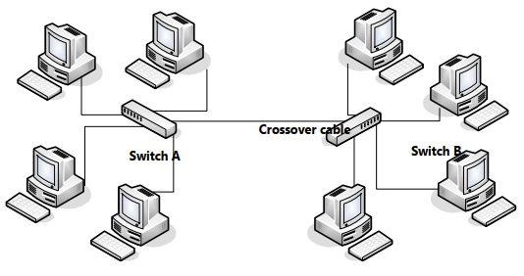

Figure 1: Network Architecture of company ABC

**Part C**

* Find the problem and provide the solution for your client. The objective of the solution is to protect the data and system inside the organization’s network.
* Define the structure and identify work breakdown schedule in **a form of a tree** and put it in as in Figure 2.

(15 marks)

Example…

Figure 2: Work Breakdown Schedule

**Assessment: [Assignment 1] – (5%) – [PO7, P4]**